26 Synchronizing Timer



This section will guide you to understand:

* How to add a synchronizing timer in JMeter

**Development Environment:**

* Apache JMeter 5.1.1 Version

This guide has two subsections, namely:

1.26.1 Adding synchronizing timer

1.26.2 Pushing the code to GitHub repositories

**Step 1.26.1:** Adding synchronizing timer

Synchronizing timer is used to synchronize requests of various threads. This means it will increase the delays between requests. By firing all threads at the same time, heavy load bursts are regenerated on your application. Steps to add synchronizing timer in JMeter are given below:

* Open Apache JMeter.
* Click on the Test Plan.
* Rename the Test Plan.
* Right click on Test Plan --->Add--->Thread(users)--->Thread Group.

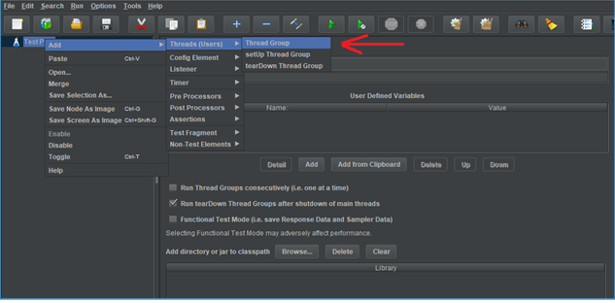

* Thread Group--->Name--->Comments---> Continue --->Thread Properties--->Number of Threads(users): ---> Ramp-Up Period (in seconds): ---> Loop Count --->Save.

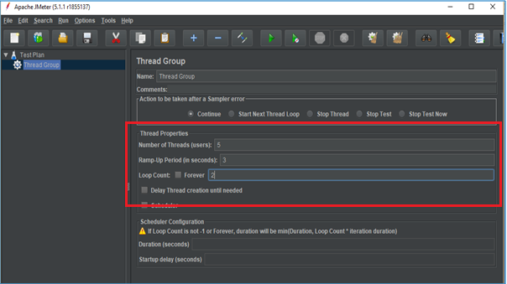

* Right click on Thread Group --->Add---> Sampler---> HTTP Request.

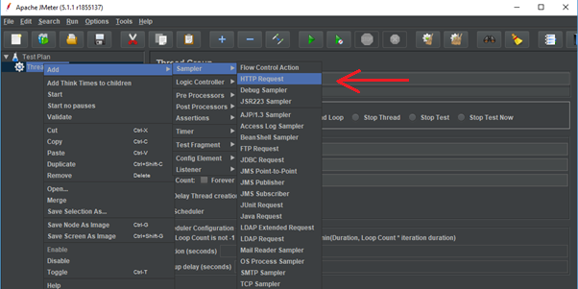

* Click on HTTP Request---> Server Name or IP :---> Path :/---> Save.

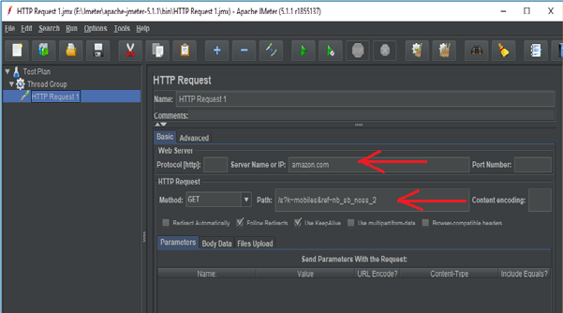

* Right click on Thread Group --->Add--->Listeners---> View Results Tree---> Run.

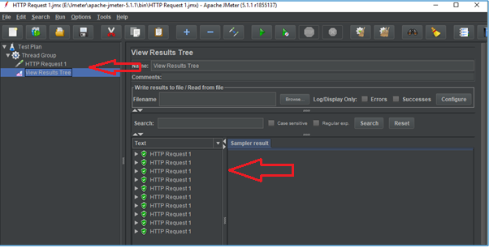

* Right click on Thread Group --->Add--->Listeners---> View Results in Table---> Clear All---> Save---> Run.

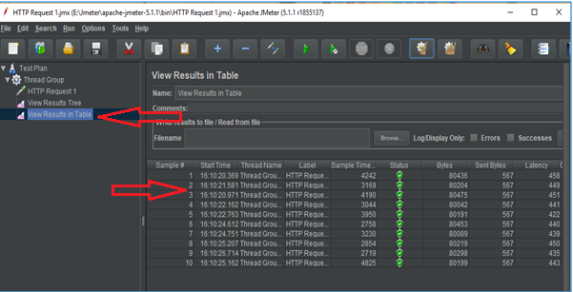

* Right click on Thread Group --->Add--->Listeners---> Assertions Results---> Clear All---> Save---> Run.

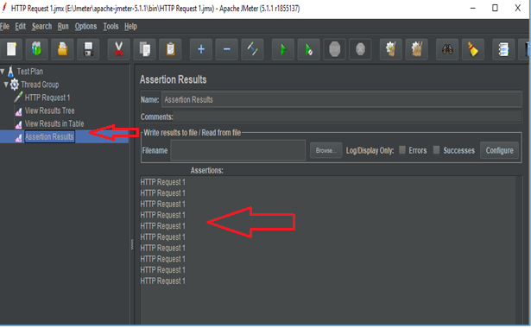

* Right click on Thread Group---> Add---> Timer---> Synchronizing timer--->Number of Simulated Users to Group by ---> Timeout in ms--->Save.

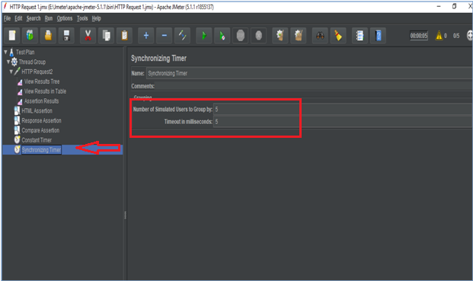

* Click on Clear all---> Run---> View Results in Table.

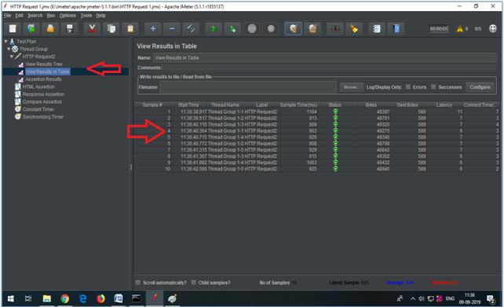

**Step 1.26.2**: Pushing the code to GitHub repositories

Open your command prompt and navigate to the folder where you have created your files.

cd <folder path>

Initialize your repository using the following command:

git init

Add all the files to your git repository using the following command:

git add . 

Commit the changes using the following command:

git commit . -m “Changes have been committed.”

Push the files to the folder you initially created using the following command:

git push -u origin master